APQB Unit 4.5 Money Markets
- The transaction demand for money is very closely associated with money’s use as a
- store of value
- standard unit of account
- measure of value
- medium of exchange
- standard of deferred payment
- Which of the following changes will necessarily occur as a result of an increase in the nominal interest rate?
- The money demand curve will shift to the left.
- The money demand curve will shift to the right.
- The money supply curve will shift to the left.
- The quantity of money supplied will decrease.
- The quantity of money demanded will decrease.
- The amount of money that the public wants to hold is $10 billion. With a monetary base of $2 billion and a money multiplier of 4, which of the following will most likely occur?
- The monetary base will increase.
- The nominal interest rate will increase.
- The money multiplier will increase.
- The money demand curve will shift right.
- Spending will increase.
- An increase in the equilibrium nominal interest rate could be caused by which of the following changes?
- An increase in the monetary base
- An increase in the money supply
- An increase in real income
- A decrease in the amount of cash the public wants to hold
- A decrease in the price level
- Assume that the economy is in equilibrium. If aggregate demand increases, nominal interest rates and bond prices will most likely change in which of the following ways?
 | Nominal Interest Rates | Bond Prices
A | Increase | Increase
B | Increase | Decrease
C | Increase | No Change
D | Decrease | Increase
E | Decrease | Decrease

- Which of the following would lead to an increase in nominal interest rates?
- An expansionary monetary policy accompanied by an increase in the demand for money
- An expansionary monetary policy accompanied by a decrease in the demand for money
- An expansionary monetary policy conducted without any change in the demand for money
- A contractionary monetary policy accompanied by an increase in the demand for money
- A contractionary monetary policy accompanied by a decrease in the demand for money
- A contraction in the money supply will most likely change the nominal interest rate and aggregate demand in which of the following ways in the short run?
 | Nominal Interest Rate | Aggregate Demand
A | Increase | Decrease
B | Increase | Increase
C | Increase | No Change
D | Decrease | Decrease
E | Decrease | Increase
- Expansionary fiscal policy will most likely result in
- a decrease in the money supply
- an increase in the marginal propensity to consume
- an increase in nominal interest rates
- a decrease in the level of output
- a decrease in the price level
- With a constant money supply, if the demand for money decreases, the equilibrium interest rate and quantity of money will change in which of the following ways?
 | Interest Rate | Quantity of Money
A | Increase | Decrease
B | Increase | Not Change
C | Decrease | Decrease
D | Decrease | Increase
E | Decrease | Not Change
- The amount of money that the public wants to hold is $10 billion. With a monetary base of $2 billion and a money multiplier of 4, which of the following will most likely occur?
1 | E | 6 | A
2 | B | 7 | C
3 | C | 8 | E
4 | B | 9 | B
5 | D | 10

- The monetary base will increase.
- The nominal interest rate will increase.
- The money multiplier will increase.
- The money demand curve will shift right.
- Spending will increase.

Include correctly labeled diagrams, if useful or required, in explaining your answers. A correctly labeled diagram must have all axes and curves clearly labeled and must show directional changes. If the question prompts you to “Calculate,” you must show how you arrived at your final answer.
- Assume Country X’s economy is currently at full employment.
(a) If country X’s net exports decrease, what will happen to the price level in Country X? Explain.
(b) Draw a correctly labeled graph of the money market, and show the effect of the change in the price level identified in part (a) on the nominal interest rate.
(c) Based on your answer to part (b), what will happen to the price of previously issued bonds?
(d) Identify an open market operation that country X’s central bank can use to offset the change in the nominal interest rate from part (b).

In answering the question, you should emphasize the line of reasoning that generated your results; it is not enough to list the results of your analysis. Include correctly labeled diagrams, if useful or required, in explaining your answers. A correctly labeled diagram must have all axes and curves clearly labeled and must show directional changes.
- Assume that Australia and New Zealand are trading partners. Australia’s economy is currently in recession.
- Now assume that Australia begins to recover from its recession. Using a correctly labeled graph of aggregate demand and aggregate supply for New Zealand, show the impact of Australia’s rising income on each of the following in the short run.
- Aggregate demand in New Zealand. Explain.
- Output in New Zealand
- Using a correctly labeled graph of the money market for New Zealand, show the effect of the output change in part (a)(ii) on the following.
- Demand for money. Explain.
- The nominal interest rate
- Assume that the price level in New Zealand rises. Given your answer to part (b)(ii), explain what will happen to real interest rates.
- Although recovering, Australia remains in recession and its government takes no action. Indicate whether each of the following curves will shift to the left, shift to the right, or remain unchanged in the long run in Australia.
- Aggregate supply
- Aggregate demand

1 | D | 6 | D
2 | E | 7 | A
3 | B | 8 | C
4 | C | 9 | E
5 | B | 10 | B

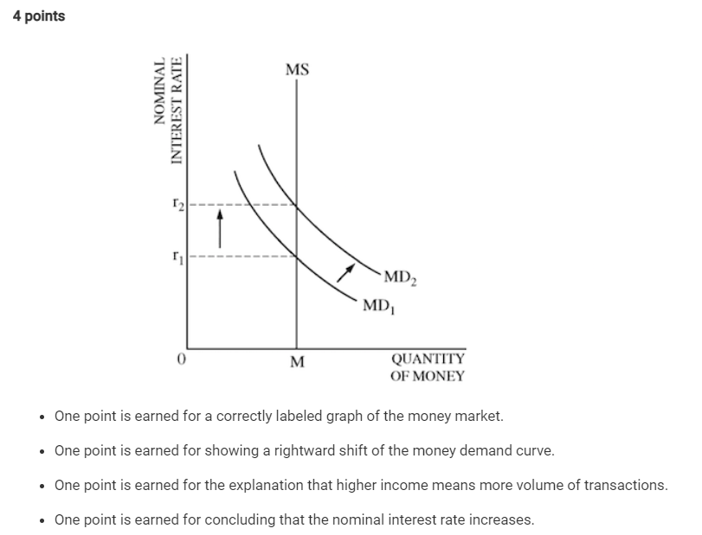
Answers

FR 10
a The response states that the price level will decrease and explains that the decrease in net exports shifts the aggregate demand curve to the left, which decreases both real output and the price level.
b The response accurately includes both of the criteria below.
A correctly labeled graph of the money market.
A leftward shift of the money demand curve and a lower nominal interest rate
c The response states that the price of previously issued bonds will increase.
d The response states that the central bank should sell bonds.

FR 11
a
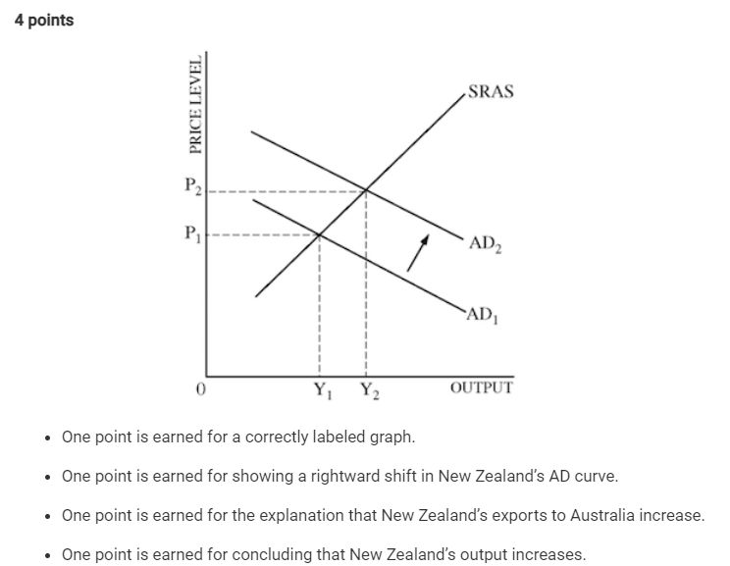
b

c One point is earned for stating that the real interest rate is indeterminate.
One point is earned for the explanation that the real interest rate is eroded by inflation but increases as a result of the increase in money demand
d One point is earned for stating that the aggregate supply curve will shift to the right.
One point is earned for stating that the aggregate demand curve is unaffected.

Full Answers

